Report Assignment 2

Name = Puruso Muhammad Hanunggul

Class = IF-39-INT

NIM = 1301153680

# Problem Description (Case Study)

In this case, we have several news that each news are have two (2) component, they are Emotion and Provocation which determine the news whether the news is hoax or not. By using Emotion and provocation we have to determine the remaining news whether hoax or not.

# Method and Design

This problem is solved by using Fuzzy System which the input is Emotion and Provocation and the output is the answer whether the news is hoax or not. Fuzzy System is one of “Reasoning” method in artificial intelligence which consist of 3 steps which are “Fuzzification” “Inference” and “Defuzzification”. In Fuzzification, the system need crisp input which is Emotion and Provocation. The system will change crisp input into fuzzy input by using the graph that already created by programmer.

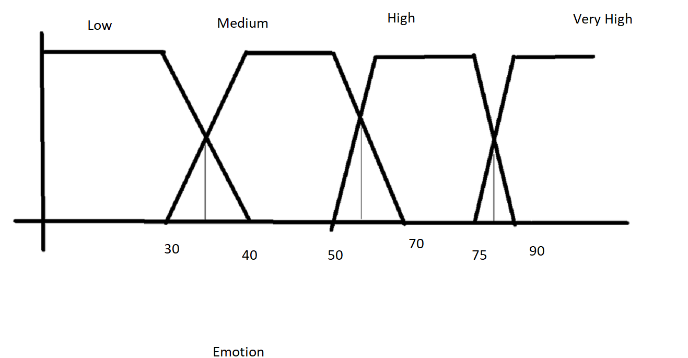

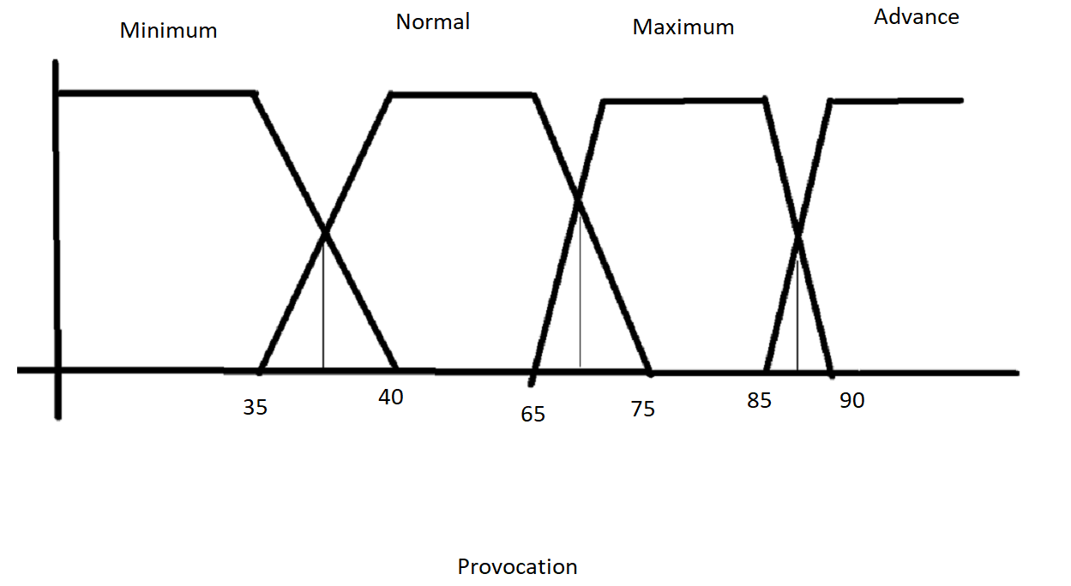

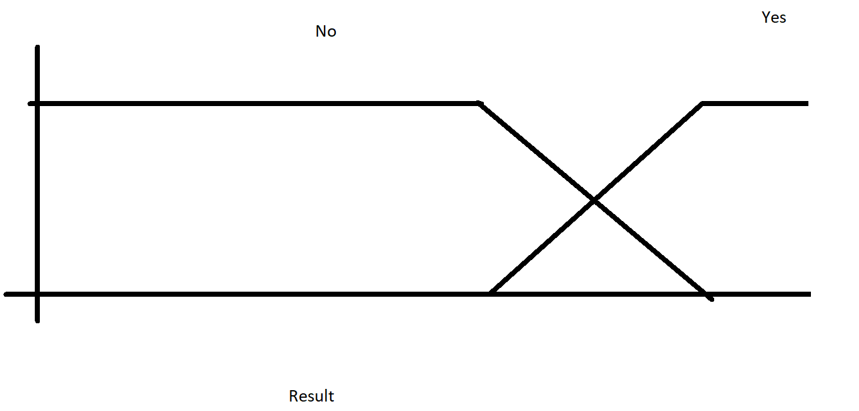

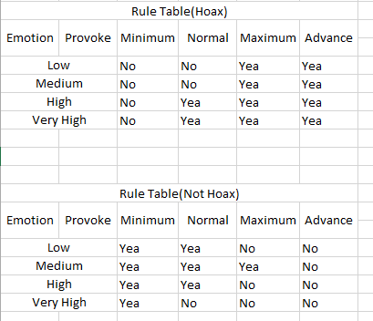

After we get the rule, program will turn the crisp value into fuzzy input, continued by inference and defuzzification. In these steps, the program will process 2 ways, which are the way of computing the “hoax” and the way of computing “non-hoax” news. The method that used in defuzzification is “Mamdani”.The program will continue until it return the crisp output. The output the result is already attached in Excel file.

# Output

